Little Cypress Junior High Band
Little Cypress Jr. High
6765 FM 1130
Orange, TX 77632

BAND HANDBOOK 2022-2023
Little Cypress Mauriceville CISD

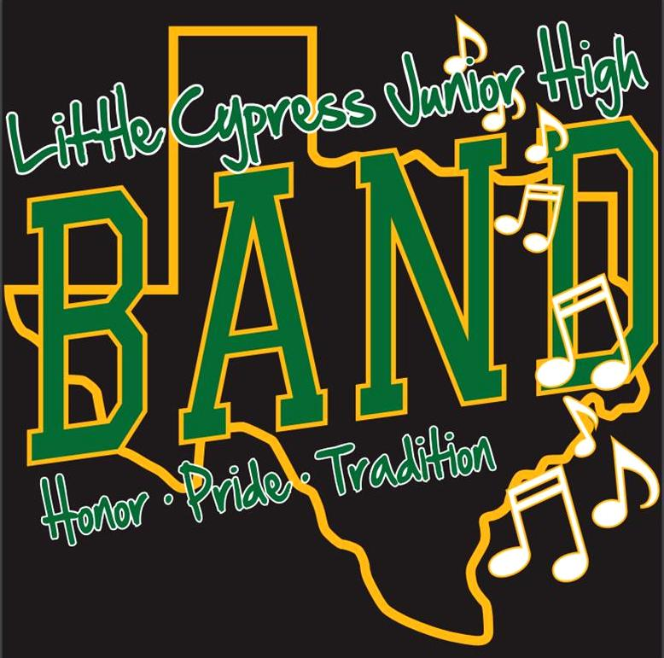

Directors:
Dan Wilhelm &
Pearce Martin

Table of Contents

Director’s Message
2022-2023 Performance Schedule
Rules/Expectations
Grading Procedures
Academic Eligibility
Band Uniforms
Concert Etiquette
At-Home Practice
Instrument Policy/Supplies
Band Travel
Private Lessons
Important Websites and Numbers
Sign Agreement/Contact Info

Dear Parents and Students,

Welcome to the Little Cypress Junior High Band Program. We are excited to have you as part of our program this year. Parents, I formally invite you to all of our performances this school year. Students, I hope you are ready for a great year!

We moved into our brand new band hall in the Fall of 2016, and we are STILL loving it! We are looking forward to a GREAT year with performances that may include pep rallies, football games, the Veteran’s Day Program, UIL Contest, concerts, and at other venues. (all public performances are subject to change) We are excited and looking forward to working with you!
The purpose of this handbook is to clarify the expectations that go with being a part of the LCJH Cub Band. Please read the entire handbook, sign the form on the last page, and return it to the band directors by the end of the first week of school.

We cannot wait to work and grow with you. Let’s have a fantastic year!

Sincerely,
Dan Wilhelm
Dan Wilhelm
Director of Bands
Little Cypress Junior High School

Little Cypress Jr. High Band
2022-2023 Calendar

- August 15, 2022 – Cookie Dough Fundraiser begins
- August 19, 2022 (Friday) – Shirt money and order forms due
- August 19, 2022 (Friday) – Instrument Drive (beginner band) 4:30pm-6:30pm at the LCJH Band Hall
- August 30, 2022 – Cookie Dough Fundraiser ends
- September 1, 2022 (Thursday) – Junior High Pep Rally – Symphonic Band
- September 22, 2022 (Thursday) – Junior High Pep Rally – Symphonic Band
- September 22, 2022 (Thursday) – Junior Football Game – Concert and Sym. Bands
- October 20, 2022 (Thursday) – Junior High Pep Rally – Symphonic Band
- October 20, 2022 (Thursday) – Junior Football Game – Concert and Sym. Bands
- October 21, 2022 (Friday) – 8th graders invited to march with the HS Marching Band @ Unity Night Football Game
- October 2022 – Band Halloween Party! TBA
- November 12, 2022 (Saturday) – ATSSB Auditions @ Silsbee Junior High
- December 3, 2022 (Saturday) – TMEA All Region Band Auditions @ Lumberton HS
- December 6, 2022 (Tuesday) – Christmas Concert 7:00 pm in Bates Gym
- January 13-14, 2023 (Friday and Saturday) – All-Region Band Clinic and Concert @ Lamar University/Nederland High School (for those that were selected in the December auditions)
- January 20 & 21, 2023 (Friday & Saturday) – ATSSB Clinic and Concert at Silsbee HS (for those that were selected in the November auditions)
- March 30 or April 1, 2023 – UIL Concert and Sight Reading @ Hardin Jefferson HS
- May 4, 2023 (Thursday) – Spring Concert 7:00 pm in Bates Gym
- May 19 or 20, 2023 (Friday/Saturday) – Spring Trip to Main Event

*All dates are subject to change
Please check LCMbands.com for the most up to date information

Rules/Expectations
Conduct:
The various bands within our program are ambassadors of the school, the district, and the community. We expect band members to be aware of the need to conduct themselves properly. Bands from LCM have always received the highest praise for their excellent manners and conduct. We expect this tradition to continue!
- Be in your seat, ready for class, when the tardy bell rings.
- Bring ALL materials to class every day.
- Be polite to other students and especially the band staff.
Grading Policy
Grading in band will depend on two categories, daily and major grades. Daily grades will consist of your weekly participation, as well as any worksheets you are assigned. Your major grades will be your playing tests and attendance at performances. An unexcused absence from a concert may result in removal from the program.
Academic Ineligibility
As mandated by the Texas University Interscholastic League (UIL) any grade below 70 on a six-week report card will deny you competitive performance privileges for a three or six week period. Because of the adverse effect this problem can have on an individual and the group as a whole, we will always monitor this situation closely, especially during football season and around All-Region and Solo and Ensemble Contest time. Parents, we ask that you continue to supervise your child and communicate with his/her teachers if any grade questions should arise. Students should understand that their grades have a direct influence on other students as well as themselves. Every individual in the band plays a vital role as a link in our chain. Consequently, when a link is missing, the chain breaks. Any on individual has the ability to prevent an entire band from performing to its full potential.
UIL Academic Requirements (No Pass, No Play)
- If a student receives a grade below a 70 in any subject, that student will become ineligible for extra-curricular activities, as defined by the UIL, starting on the Friday following the end of the six-week grading period in which the failing grade was received.
- A student can regain eligibility on the Friday following the three-week grading period if the student is passing EVERY class and receives no remark of “currently failing” on his/her 3-week progress report.
*The directors can answer specific situational questions as they may arise.
Classroom Behavior
To redirect student behavior, the following consequences will be issued:
- Verbal Warning (4 Questions)
- Written Warning/Refocus Questions/Sign Book
- Contact Parent
- Detention (Refocus Questionnaire) or Appropriate Consequence
- Office Referral

Band Uniforms
The dress for all concerts will be black slacks with tucked in band polo and black shoes with black socks. Girls may wear a below the knee black skirt. Groups performing at UIL concert and sight reading evaluation will wear “concert black”… which is the bottom half of Concert dress with the addition of a white long sleeve button down shirt. Girls may wear an all black dress with black or dark shoes.
*Concert and Symphonic band students are required to purchase a band T-shirt and a band polo for more formal performances.
These guidelines are not meant to infringe on a student’s right to self-expression. They are designed to maintain uniformity among band members. Failure to comply with these guidelines can result in a student being removed from the performance in question, resulting in a lower grade. All dress should comply with the student dress code, found in the LCJH Student Handbook.
Concert Etiquette
Audience manners are based on a respect for performers and for other members in the audience. They are expressions of courtesy. Unfortunately, young people today are seldom exposed to formal concert situations and are often unaware of the standards of appropriate behavior. When attending concerts throughout the year, LCJH band members will be expected to display appropriate behavior in the audience while listening to their peers perform.
By following these guidelines, you can help us set the proper example for our students and will make the concert more enjoyable for all.
- Avoid entering or leaving the auditorium/performance venue while a group is performing. If necessary, move only between pieces while there are no groups performing.
- Applause is welcomed, but whistling or cheering is inappropriate for a formal concert.
- Talking is inappropriate during a performance. Young children who are talking or crying should be escorted out of the performance area.
- Attention should be directed to the performing group at all times.
- Cell phones, texting devices and other electronics should be turned off. This can be very distracting to the audiences, and can ruin a band’s performance.
Please remember that you lead the entire audience by your example.
At-Home Practice
Consistent at-home practice is essential for a student to progress at an acceptable rate on his or her instrument. Parents, we encourage your child to adopt a routine to practice every day. Past experience has shown us that students who are practicing and making noticeable progress on their instrument are more likely to enjoy band than those who do not practice. Just as with anything else that is worth learning, there are parts of learning an instrument that are not as fun as others. Often, as the newness wears off, practicing becomes more “work”. When this happens, please encourage your child to push through the difficult parts, and they will become easier in time.

Instrument Policy/Supplies
All students, with the exception of those who play oboe, bassoon, French horn, baritone or tuba, will be required to rent or purchase their own instrument. Students with school issued instruments will be required to purchase a mouthpiece. Since we do not charge students to use school issued instruments, the student will be required to pay for any repairs above normal wear and tear. Swicegood Music in Nederland offers rental plans if you prefer not to buy an instrument. The band will furnish music and folders for the students. Students must have their instrument in working condition and they will be responsible for reeds, reed case, oil, sticks, or any other supplies that pertain to their instrument. Supplies can be purchased from the band staff at a discounted rate. A price list is displayed in the band hall for all supplies.
All percussionists will need to purchase sticks, mallets and a stick bag and have those at class every day.
Band Travel
The Little Cypress Jr. High Band represents the entire school, as well as the LCM CISD. Students must be in good standing with the school in order to travel with the band. All school rules still apply on field trips. When traveling with the band, students are expected to follow all directions as set forth by the directors and chaperones. All adults are to be treated with the utmost respect. Band members will always make every effort to be courteous and respectful.
Private Lessons
We are very fortunate at LCM to have a private lesson program. We offer teachers for every band instrument and have some scholarships available. As a classroom teacher, it is impossible to consistently instruct every student on a one-on-one basis. Private lessons, however, provide your child with a weekly 30-minute instructional period with a professional teacher/performer on their specialized instrument. This allows students to progress at their own pace with supervised qualify instruction. They are held on either Monday or Tuesday after school and will begin on TBA. If you have a specific time you need for your child’s lesson, please turn in the enrollment paperwork as soon as possible.
Instrument Cabinets
Students using an instrument cabinet are not to use their own personal key or combination locks.
Important Websites and Numbers
- LCM Bands Website: http://LCMbands.com
- LCJH Band Face Book Page: LCJH Band
- Texas Music Educators Association: http://tmea.org
- LCJH Band Hall: (409) 670-4621 ext. 3010
- Swicegood Music: (409) 833-8603

Interpretation of Policies and Regulations
This handbook has been prepared as a general guide to the operation of the Band Department in the Little Cypress Mauriceville Schools. It must be understood that the students with whom this department deals are all individuals. Therefore, it is necessary to understand that every infraction is unique, and the Director of Bands has the authority to render all judgments concerning any matter pertaining to the overall band program and its operation.

Student Information Sheet 2022-2023
Student Name:_______________________________________________________
Mailing Address: _____________________________________________________
___________________________________________________________________
Parent Name:________________________________________________________
Parent Cell Phone #:___________________________________________________
Parent Email:________________________________________________________

I understand that the band handbook contains information that my student and I may need during the school year and that all students will be held accountable for their behavior and will be subject to the policies outlined in the Little Cypress Junior High Band Handbook. If I have any questions regarding this handbook, I should direct those questions to the Director of Bands.

Signature of Student___________________________________________________

Signature of Parent/Guardian ___________________________________________

